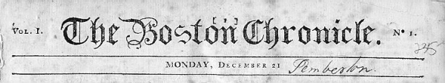
Washington’s Retreat News Broadcast

This just in! George Washington has just lost the city of New York to the invading British! Now, he and the Continental Army are on a desperate retreat though New Jersey. You are all young recruits for one of the nation’s most prominent newspapers, The Boston Chronicle and you are tasked with covering the story of Washington’s retreat between November and December of 1776. It is your job to report the significant occurrences or storylines that the American public should know based on where General Washington and his men are staying. You should do this in the form of a 1 to 2-minute audio newsreel that spreads word of the Continental Army’s travels in a brief but effective way. Your broadcast should include:
- Where the Continental Army is staying (town or house names)

- Relevant dates
- A recap of important events that have taken place, be sure to be historically accurate and use your own words!

- A brief creative news segment- this can be anything from a historically prevalent sponsor to other historical news that could be happening around the same time.

- Proper grammar and clarity of the information presented.

Retreat Point: Period:
Directions: Draft your script for your radio broadcast below! Be sure to include: where the Continental Army is staying (town or house names), relevant dates, a recap of important events that have taken place, be sure to be historically accurate and use your own words, a brief creative news segment (this can be anything from a historically prevalent sponsor to other historical news that could be happening around the same time), and proper grammar and clarity of the information presented.

_________________________________________________________________________________________
_________________________________________________________________________________________
_________________________________________________________________________________________
_________________________________________________________________________________________
_________________________________________________________________________________________
_________________________________________________________________________________________
_________________________________________________________________________________________
_________________________________________________________________________________________
_________________________________________________________________________________________
_________________________________________________________________________________________
_________________________________________________________________________________________
_________________________________________________________________________________________
_________________________________________________________________________________________
_________________________________________________________________________________________
_________________________________________________________________________________________
_________________________________________________________________________________________

Retreat Stop | Dates | Important Information (summarize major events that took place there!)
Hackensack
River Edge
Leonia
Acquackanonk Township (Passaic)
New Brunswick
Basking Ridge
Princeton, Trenton, Morrisville, PA

